**Devops-CI-CD-Project with Jenkins**



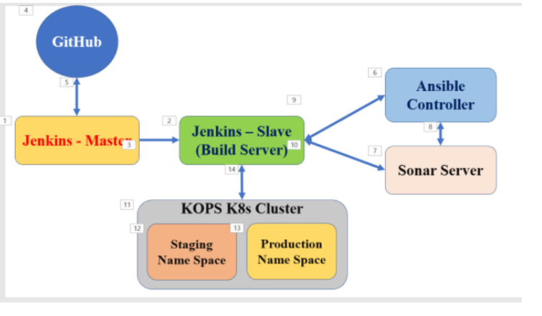

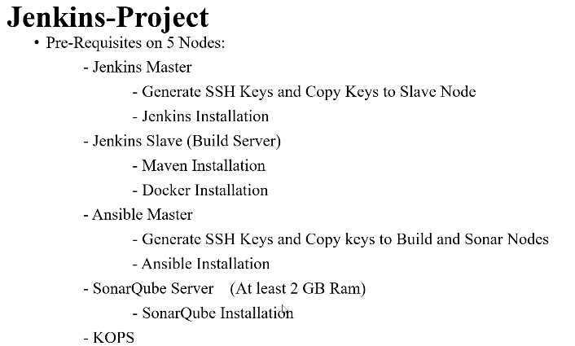

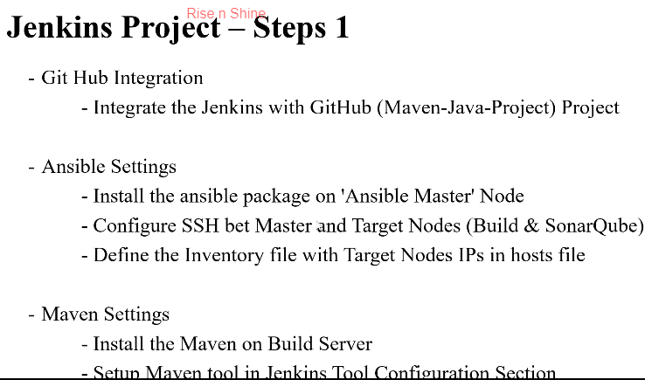

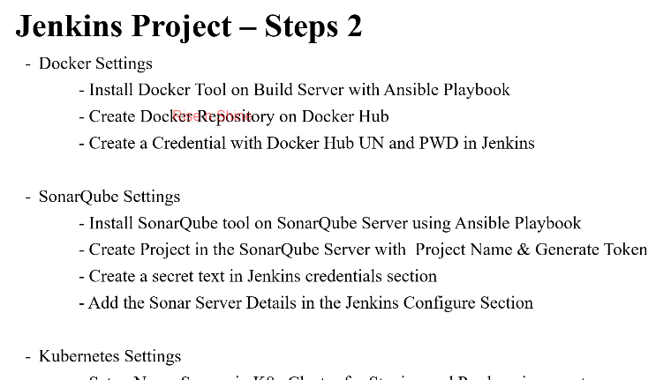

-Set up Name spaces and K8 Cluster for staging and production

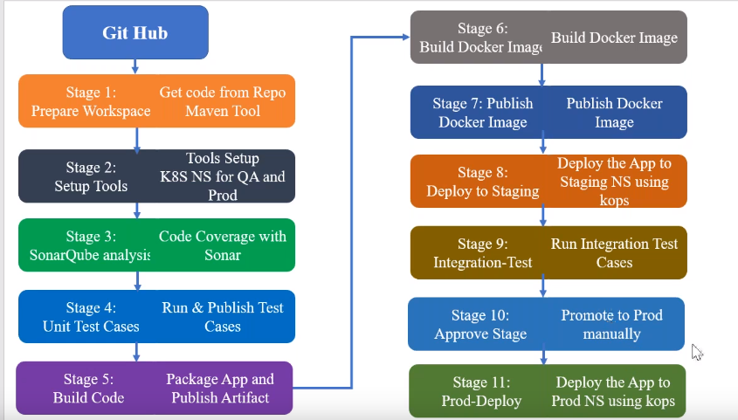

# Jenkins-Project

5 Nodes:

- Jenkins Master

- SSH Keys

- Jenkins Installation

- Jenkins Slave (Build Server)

- Maven Installation

- Docker Installation

- Ansible Master

- SSH Keys

- Ansible Installation

- SonarQube Server

- SonarQube Installation

- KOPS

- K8s Cluster Create it and update it.

Required Tools and Settings:

----------------------------

- Git Hub Integration

- Integrate the Jenkins with GitHub (Maven-Java-Project) Project

- Ansible Settings

- Install the ansible package on 'Ansible Master' Node

- Configure SSH 'Password less login' bet Master and Target Nodes (Build Server & SonarQube)

- Define the Inventory file with Target Nodes IPs in hosts file

- Maven Settings

- Install the Maven on Build Server

- Setup Maven tool in Jenkins Tool Configuration Section

- Docker Settings

- Install Docker Tool on Build Server with Ansible Playbook

- Create Docker Repository on Docker Hub

- Create a Credential with Docker Hub UN and PWD in jenkins

- SonarQube Settings

- Install SonarQube tool on SonarQube Server using Ansible Playbook

- Create Project in the SonarQube Server

- Project Name

- Generate Token

- Install Sonarscanner plugin

- Create a secret text in Jenkins credentials section

- Add the Sonar Server Details in the Configure Section

- Kubernetes Settings

- Setup Name Spaces in K8s-Cluster for Staging and Prod environments

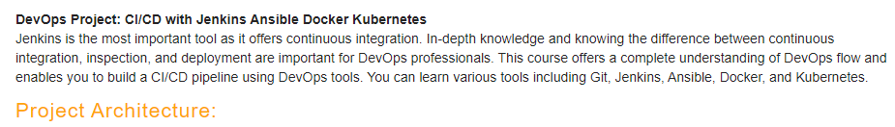

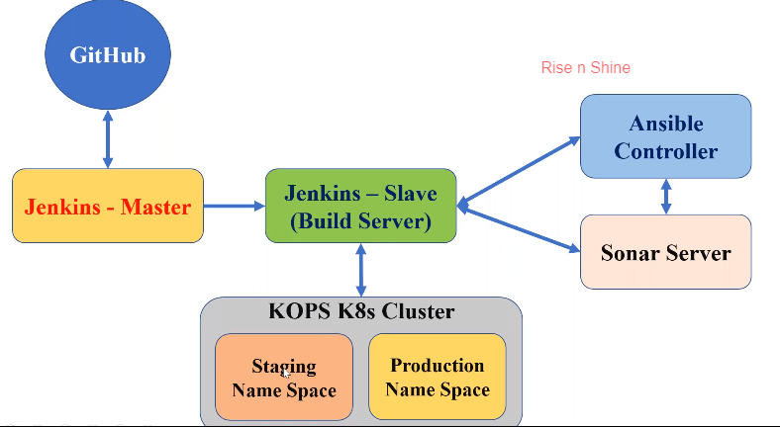

Agenda:

-Pipeline template is using Ruby scripting code

-Now we are going to do complete CI-CD project

-We need to have Jenkins-Master and Jenkins-Slave(Build server)

-we need to take the code from Git and configure with Jenkins

-next by using Ansible controller to install Sonar Qube for code analysis on Sonar Node

-and docker and maven on build server using yaml files

-once war file is ready in Build server we need to create docker image

-need to have SSH communication between all these instances refer the blue arrow mark for SSH option

-once docker image is ready, we are going to take Kops cluster node and deploy the docker image on staging and production name spaces

-first we are going to deploy in staging name space and running integration test cases and that is done next we need to deploy in production name space

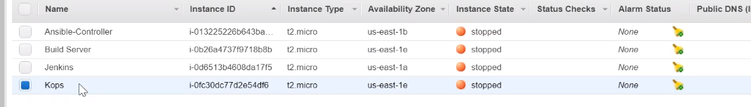

-we already have Kops, Jenkins master, Jenkins Slave (Build server), Ansible-controller

-now we need to launch Sonar server with minimum 2GB RAM required and launch ec2 instance as we need to have 5 nodes to complete this CI-CD project

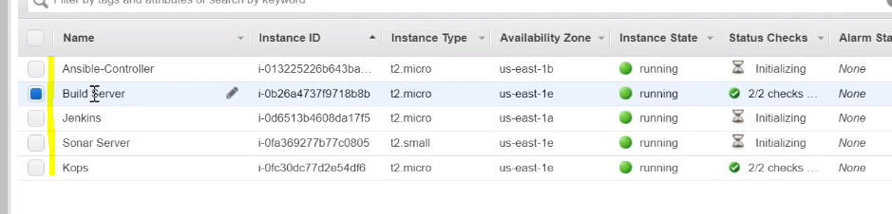

-we already have SSH communication between Jenkins master and build server

-now we are going to create SSH communication between Build server to Ansible controller and Sonar Qube server with using Private IP addresses

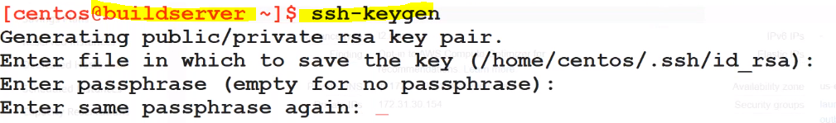

-copying ssh key to ansible controller

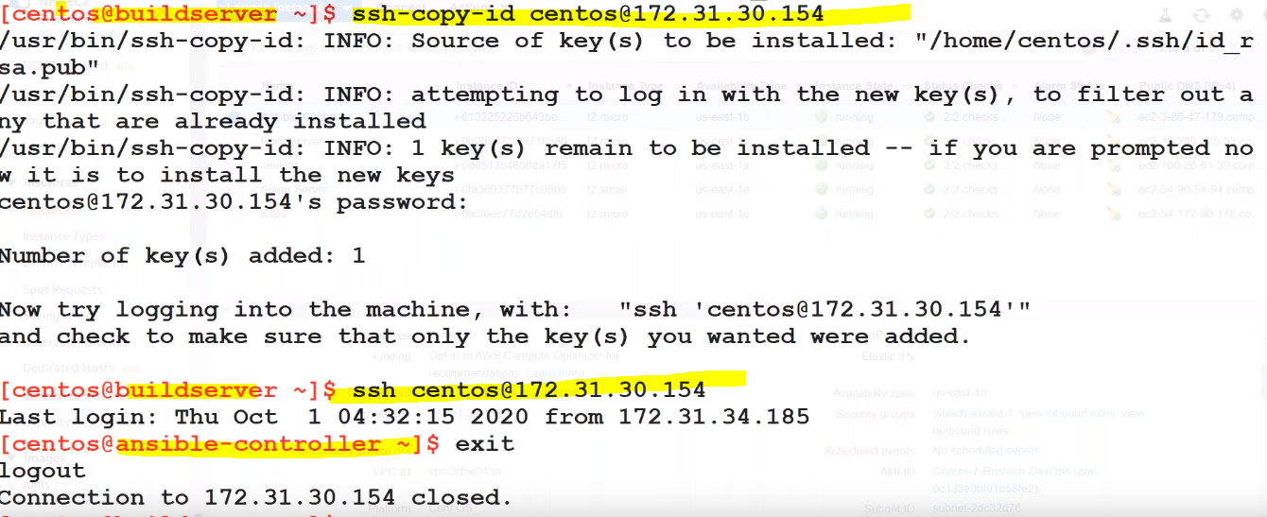

-copying SSH key to sonar server

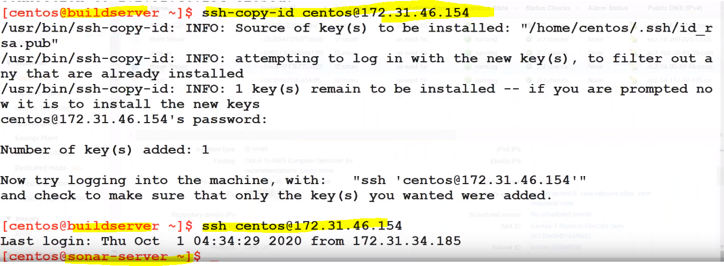

-Now we need to create SSH connection between Ansible controller to Build server for installing docker on build server

-next ansible controller to sonar qube for installing sonar on sonar server

-same as above steps

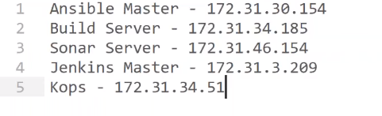

-copying ssh key to build server

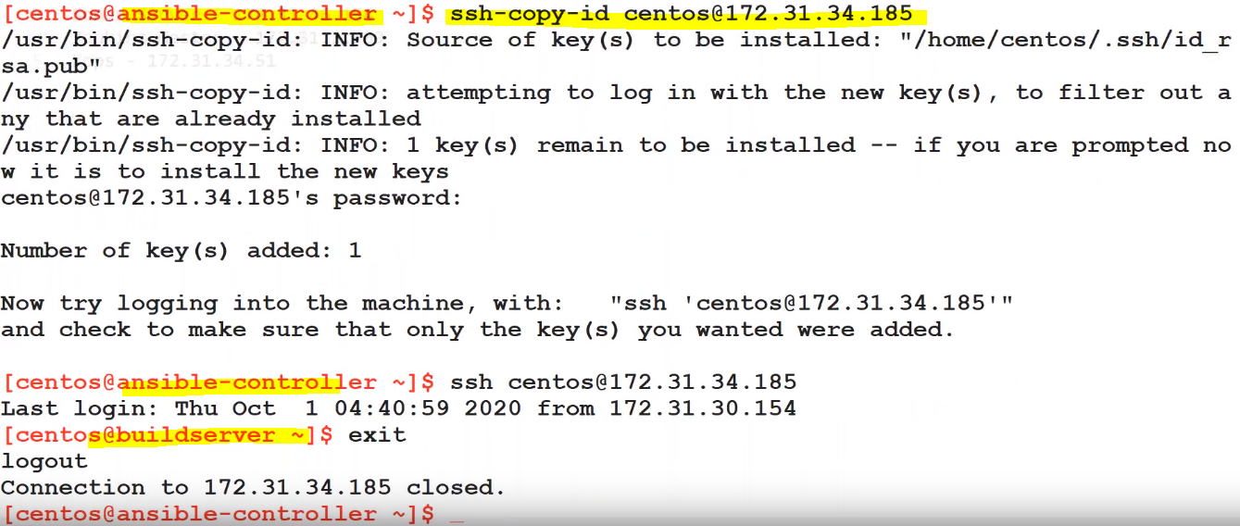

-copying ssh key to sonar server

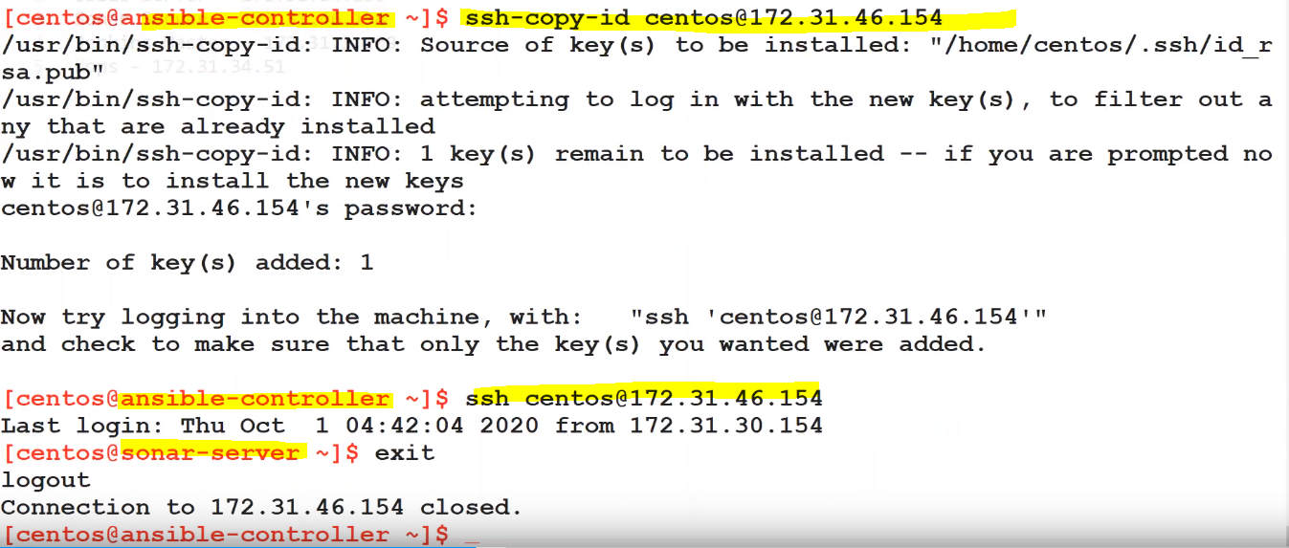

-now we need to have SSH communication between Kops and build server

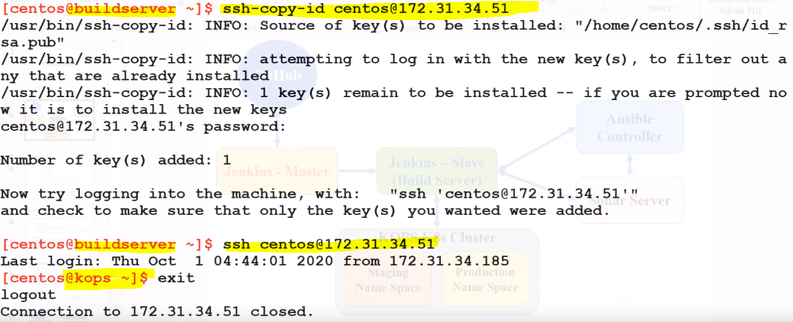

-Now we have SSH communication to all required systems



Steps:

Step 1:

-Git hub integration with pipeline script

-Go to Jenkins section create a Job with Pipeline approach

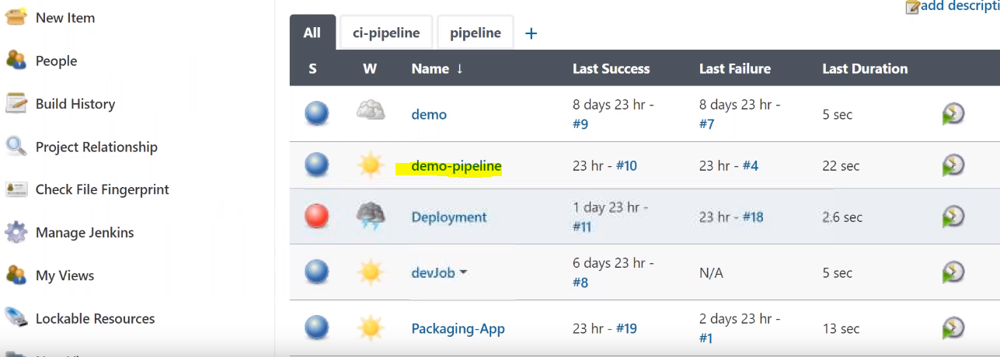

-Configure the below options:

-define Poll SCM(H/2 * * * *) for automating the build starts whenever the code update in git hub

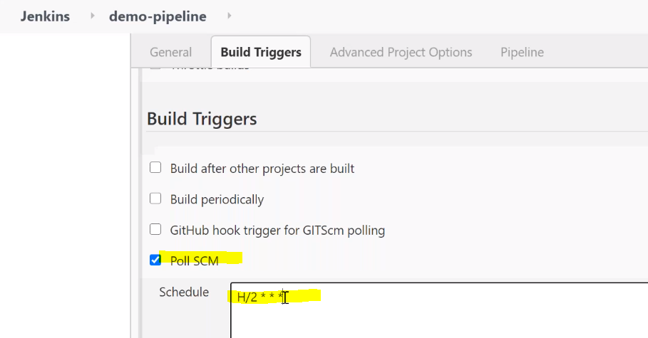

-now go to Pipeline section and define Git Hub URL and credentials

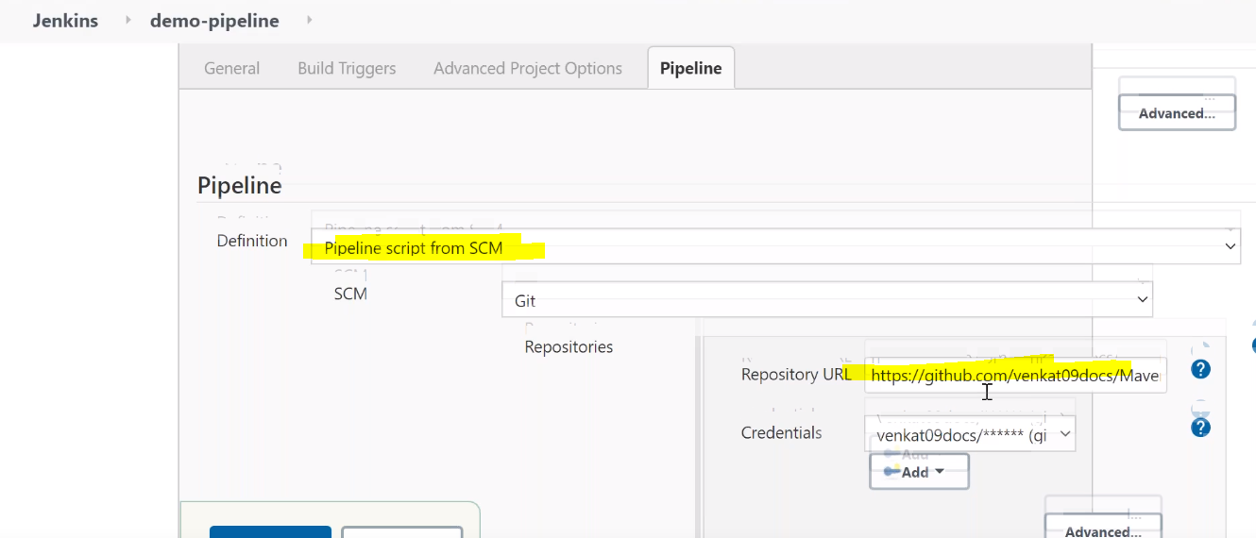

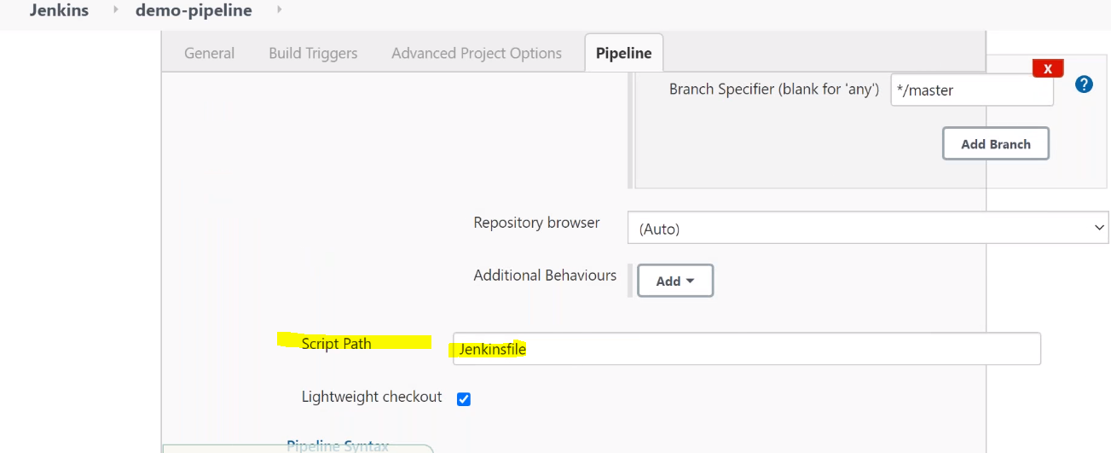

-save and apply and trigger the build for any issues or exceptions

-in the above git project location we added Jenkinsfile in that we have added the Maven tool and Github url integration

pipeline {

agent none

stages {

stage('Prepare Workspace') {

agent {

label 'BuildServer'

}

steps {

// Get src code from a GitHub repository

git credentialsId: 'github_un-pwd', url: 'https://github.com/venkat09docs/Maven-Java-Project.git'

stash 'Source'

script{

mvnHome = tool name: 'maven3.6', type: 'maven'

}

}

}

-now we are going to copy yaml file and inventory file to ansible controller using build server in Jenkins for installing docker and sonar qube by using pull the maven-project code to ansible-controller

Hosts file:

[build]

172.31.48.153

[sonar]

172.31.17.13





-by defining the below code in JenkinsFile

def remote = [:]

remote.name = 'ansible'

remote.host = '172.31.30.225'

remote.user = 'centos'

remote.password = 'Rnstech@123'

remote.allowAnyHosts = true

stage('Setup Tools'){

agent {

label 'BuildServer'

}

steps{

sshCommand remote: remote, command: 'cd Maven-Java-Project; git pull'

//sshCommand remote: remote, command: 'cd Maven-Java-Project; ansible-playbook -i hosts tools/sonarqube/sonar-install.yaml'

//sshCommand remote: remote, command: 'cd Maven-Java-Project; ansible-playbook -i hosts tools/docker/docker-install.yml'

}

}

-first we need to have the repository then we can pull the updated code from git hub to ansible-controller

-so we need to clone the github in ansible-controller first

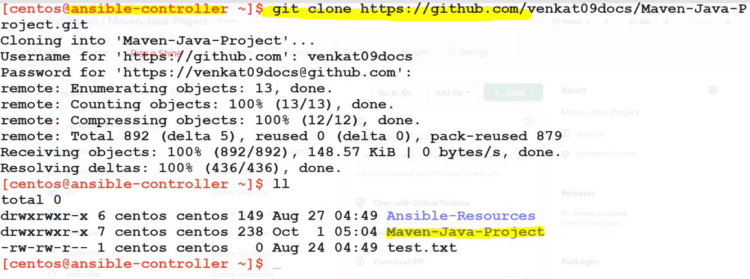

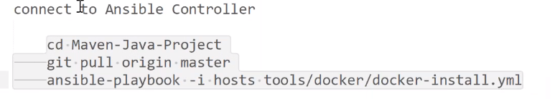

-for connecting build server to ansible controller to run the above commands we need to install one plugin as SSH Pipeline Steps plugin

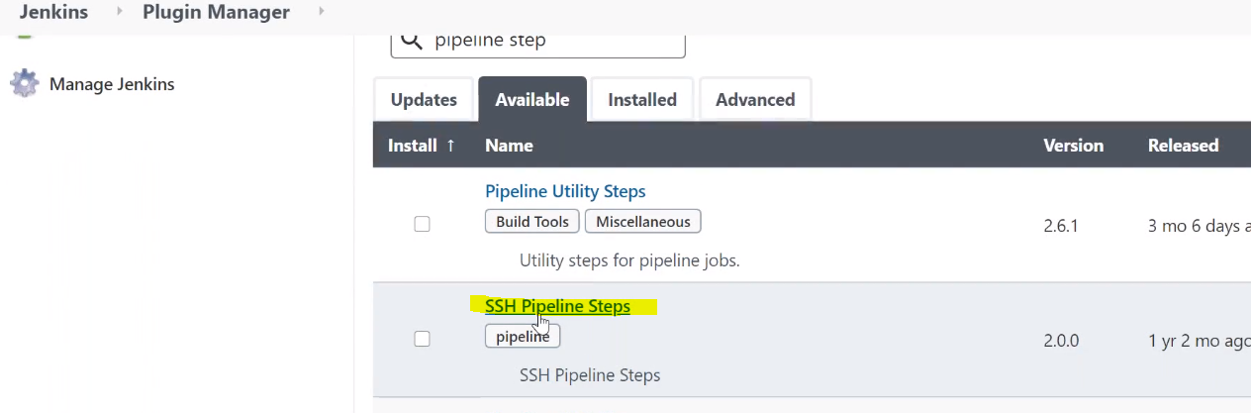

-for connecting the ansible-controller using the above plugin we need to declare the IP address username, password and hostname for SSH communication

***

-Instead of hard coding the username and passwords we can use withCredentials options in the script

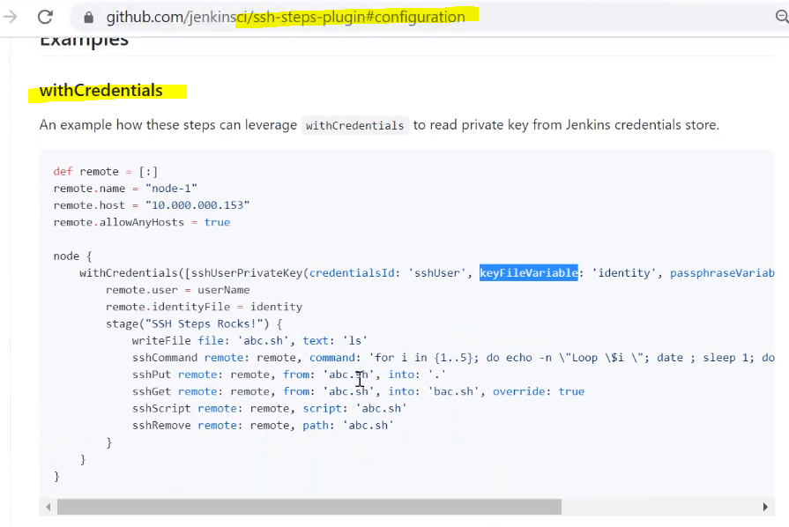

-so install SSH Pipeline Steps plugin

-we also need to create stage and production name spaces using yml files in kops system using same plugin

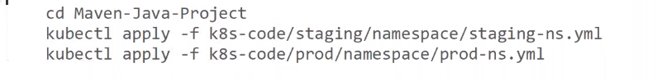

def remote1 = [:]

remote1.name = 'kops'

remote1.host = '172.31.62.36'

remote1.user = 'centos'

remote1.password = 'Rnstech@123'

remote1.allowAnyHosts = true

//K8s Setup

sshCommand remote: remote1, command: "cd Maven-Java-Project; git pull"

sshCommand remote: remote1, command: "kubectl apply -f Maven-Java-Project/k8s-code/staging/namespace/staging-ns.yml"

sshCommand remote: remote1, command: "kubectl apply -f Maven-Java-Project/k8s-code/prod/namespace/prod-ns.yml"

 

-now we need to start Kops cluster then only we can run above kubectl apply command otherwise it will fail

***

-Jenkins like to send notifications to email server, we need to integrate(Host, UN, PWd) Jenkins with gmail server

-Like above point, we need to integrate(URL, Token) with Sonar server for code coverage

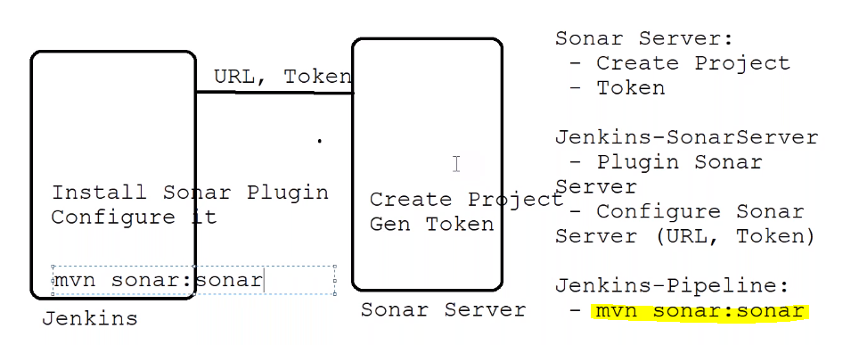

-For Sonar server we need to do below options:

-we need to create one project and Token key

-then in Jenkins we need to install sonar server plugin and configure with sonar server with URL and Token key

-now we have configured sonar with Jenkins

-now we need to run the code coverage reports using below command

-mvn sonar:sonar

-maven tool providing the above command to run the code coverage reports

-whenever we run above command it will communicate with sonar and copy the code in sonar server and run the code coverage reports

-we launched kops cluster and created cluster so it will launched master and nodes

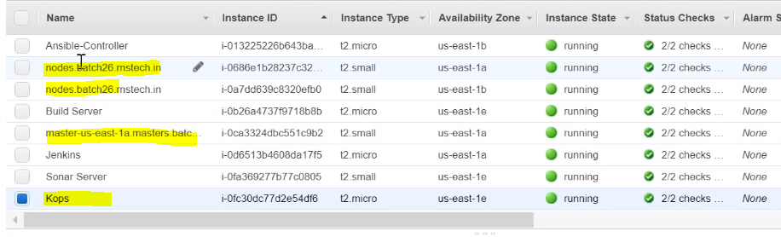

-now run the build and check the build success or not

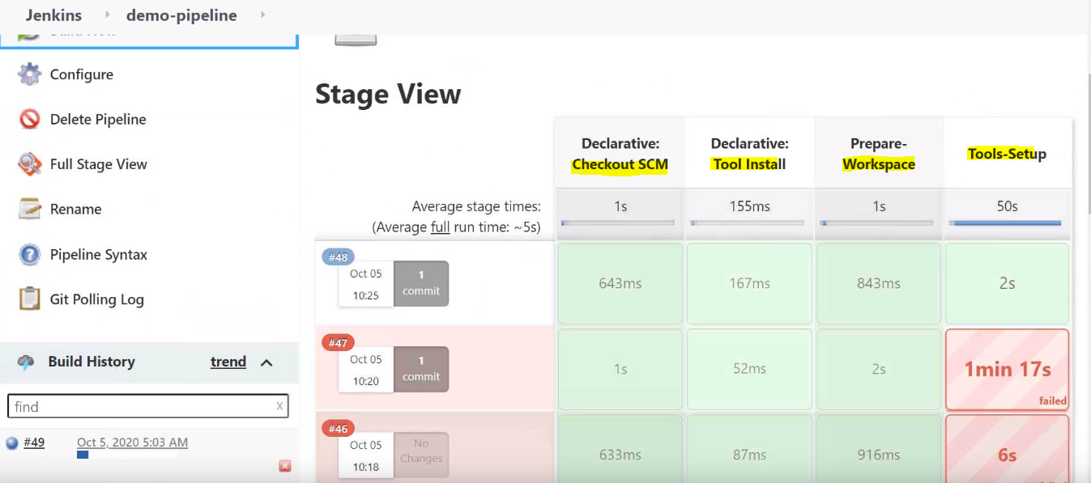

-first time we need to clone git to kops, build server and ansible-controller

-after successful build, it will create staging and production namespaces in kops system

-and docker install in build server and sonar install in sonar qube

-verify the above steps are done correctly/installed correctly or not by manually

-if sonar not installed properly with shell script use ansible galaxy for readymade role in easy way

$

ansible-galaxy install lrk.sonarqube

<https://galaxy.ansible.com/lrk/sonarqube>

using in yaml file and upload in git hub in tools/sonarqube/ansible-role-sonarqube/

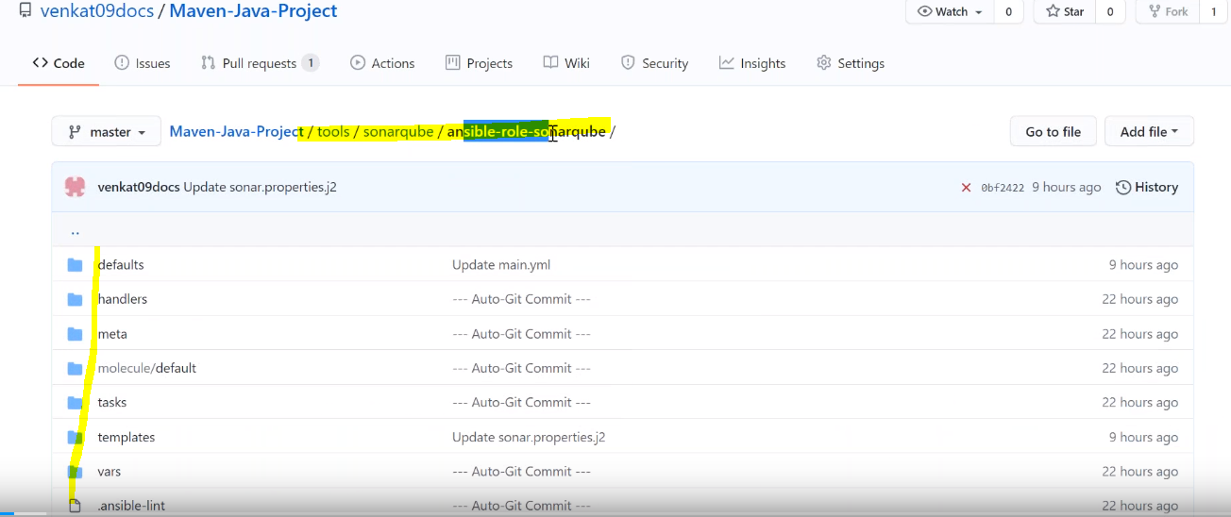

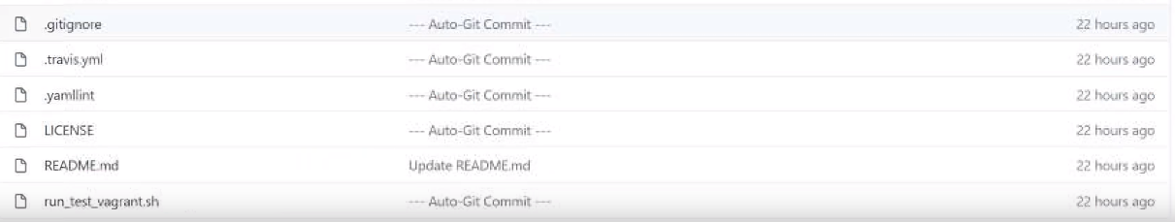

-and in sonar-install.yml file add the above sonarqube role

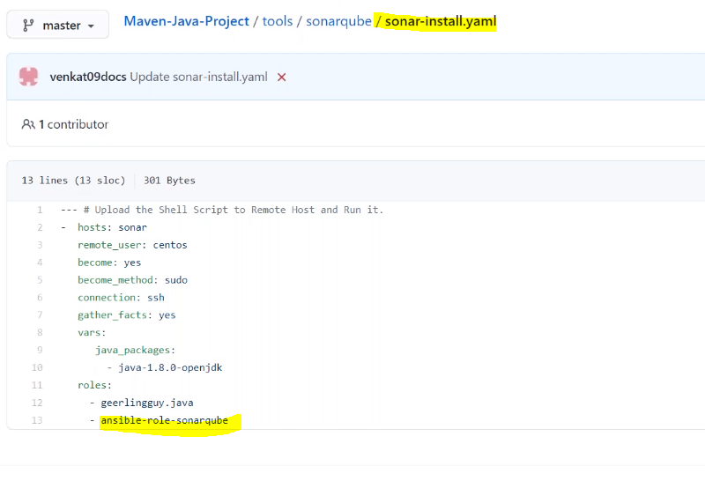

-now check the build success or not and also check sonar installed and started as a daemon service or not

-if sonar successfully started as a service use the url to check sonar running or not

<http://IP:9000>

-9000 default port number of sonar

-if any issues login to sonar system and check the log

/var/log/sonarqube/es.log

/var/log/sonarqube/web.log or check $./sonar.sh console



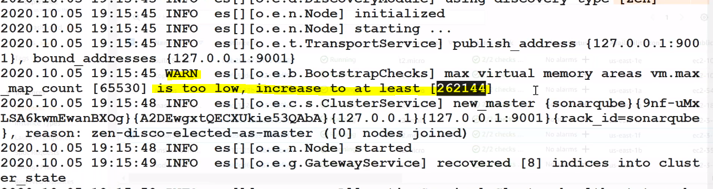

-so memory not supporting so we need to change the memory

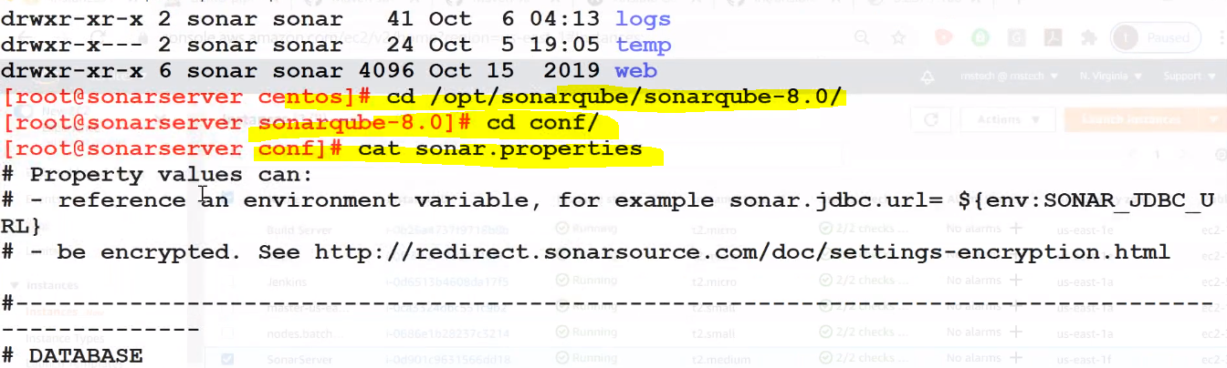

-and increase the size of the below java_opts in maven-java-project/tools/sonarqube/ansible-role-sonarqube-defaults/main.yml

-1024 in both places

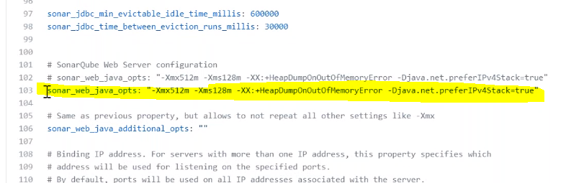

-if still getting the same issue, launch new sonar server with 4GB RAM and change private IP in host file and create ssh connection between build server to new sonar server and ansible-controller to new sonar server

-and check the security group with custom TCP 9000 port

-and check the URL for accessing sonar qube

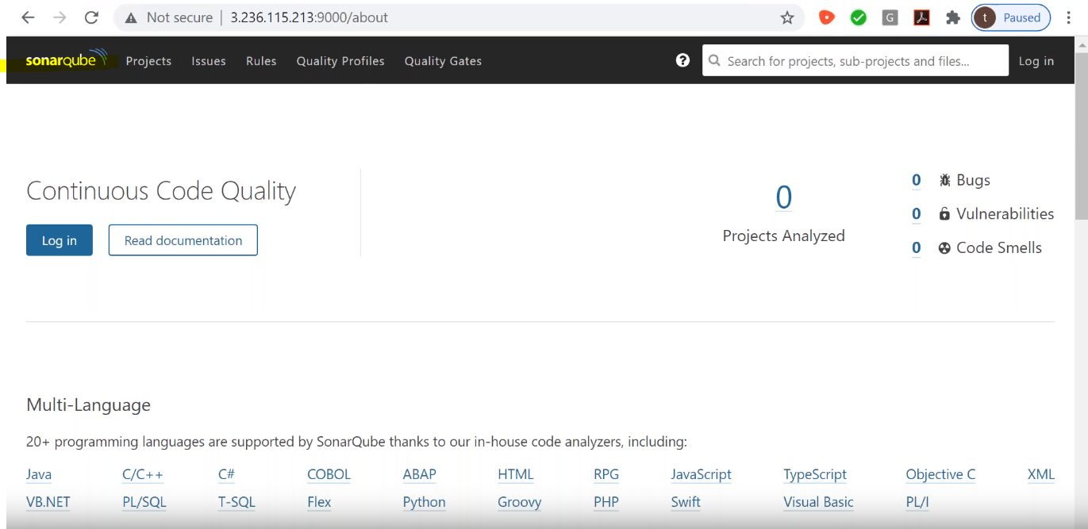

-we need to login sonar with username and password:

UN -admin

PWD -admin

****

-we are using this sonar for analyze the code metrics and statistics, and duplication of code, security point of view, size of the code, coverage point of view

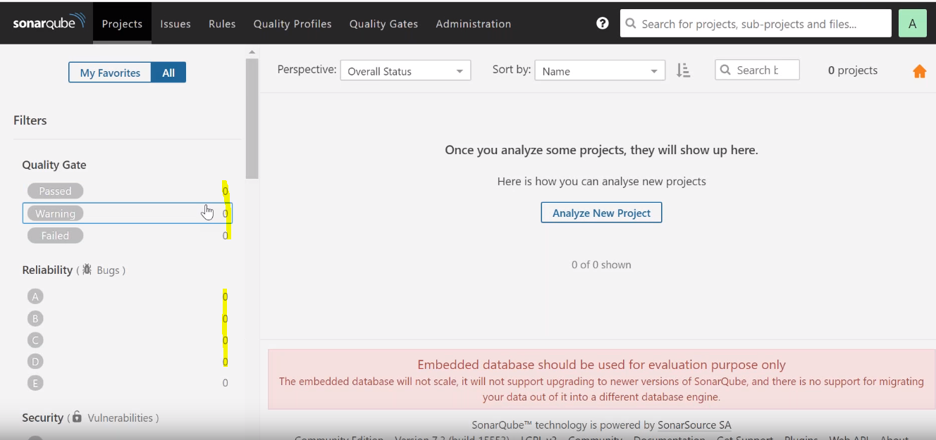

-Main usage of sonar:

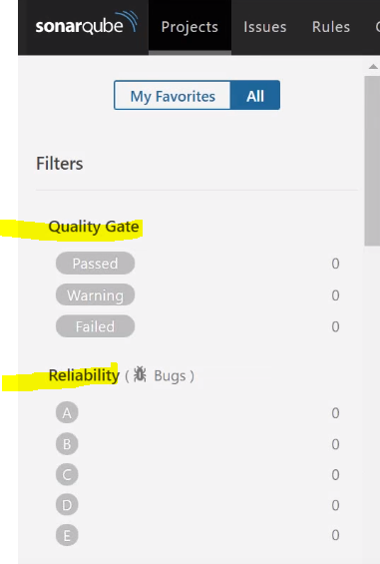

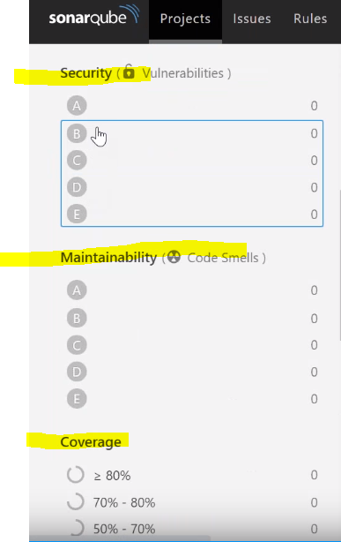

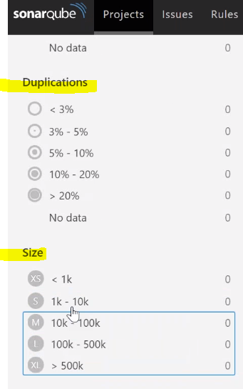

-sonar is supports not only specific to java, it is supporting multiple technologies

-now sonar is up and running, now we need to create project and token key

-creating project in sonar:

-click on analyze project option

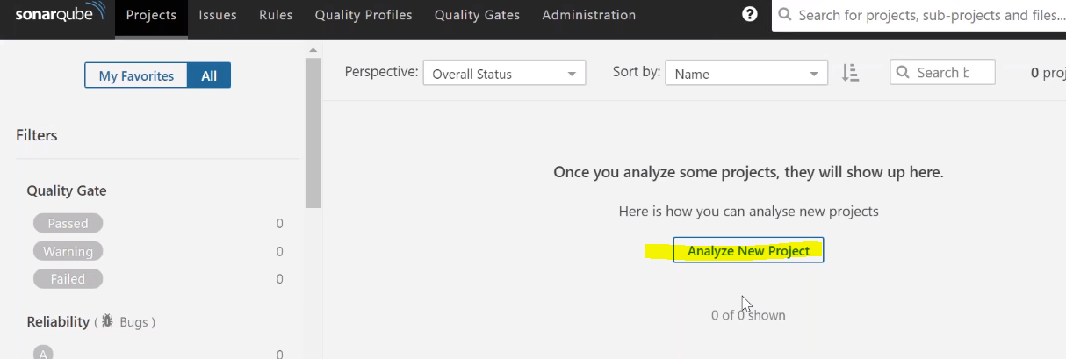

-and enter project name and generate the token key

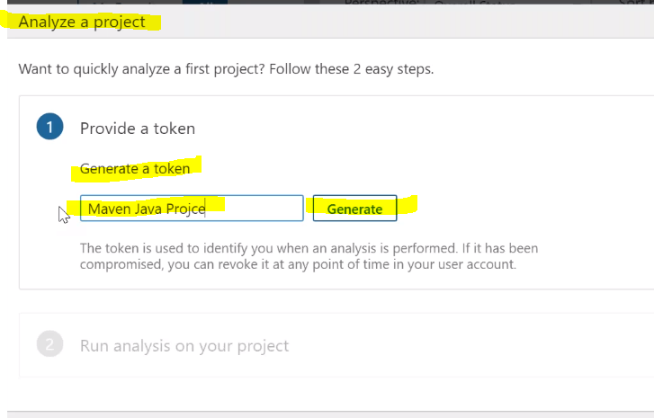

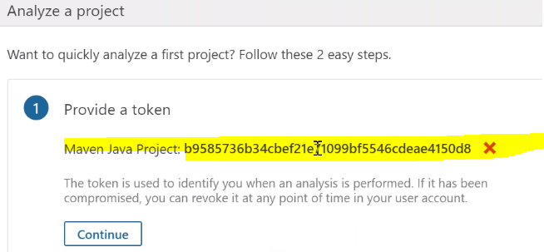

-we need to use this token to authenticate the project

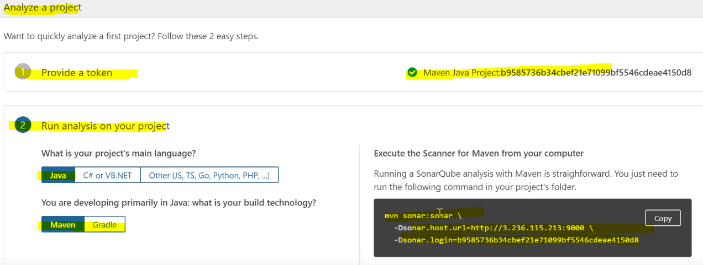

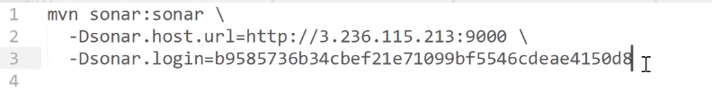

-now we can use the above code for integrate sonar server with Jenkins or we can use another below option with sonar plugin for integration

***

-we need to compile the source code first otherwise sonar is not going to take to code for analysis

-instead of using the token key directly in the script we are going to use the SonarQube Scanner plugin

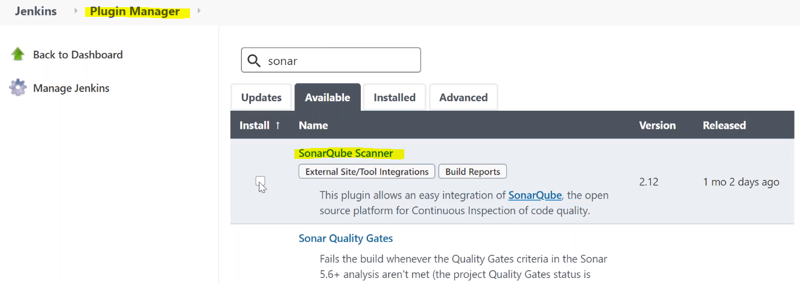

-Install SonarQube plugin in Jenkins console

-Go to Manage jenkins and configure system

-in that you will find SonarQube server

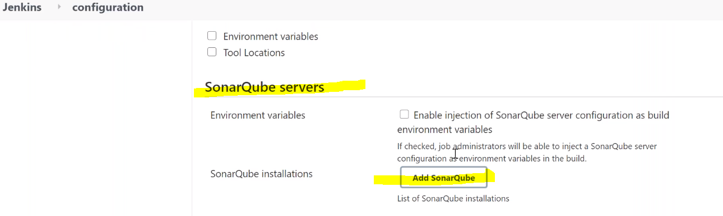

-now add the sonar qube server details

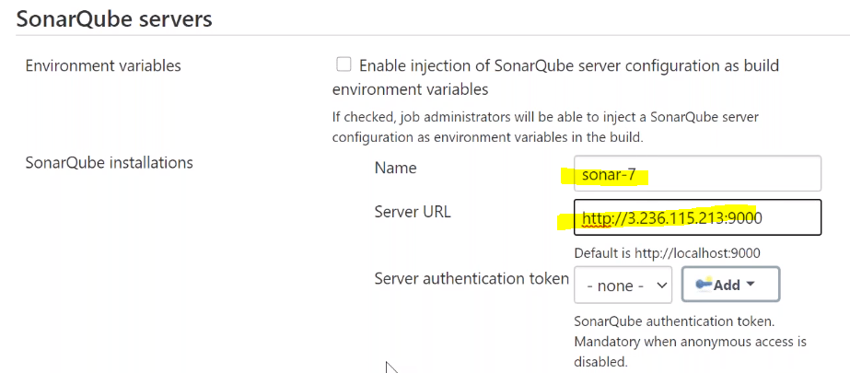

-add name and URL and then add the server authentication token key

-after clicking Add option you need to select secret text option

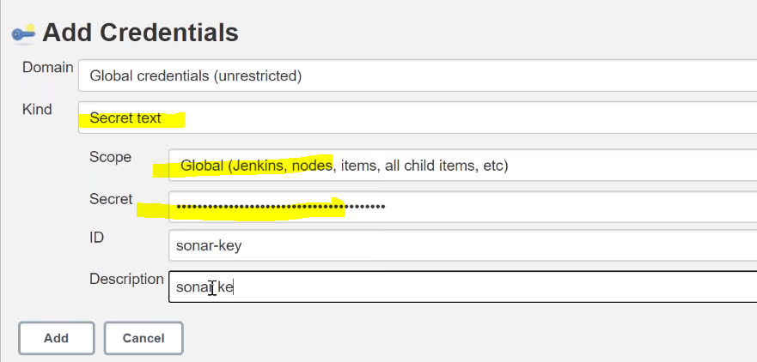

-add the token key and click on add option

-now we integrated the sonar server with Jenkins

-go to demo-pipeline job and click on pipeline syntax option

-and select withSonarQubeEnv: Prepare SonarQube Scanner environment

-by using the above option we can generate the code like below and add this in Jenkinsfile

stage('SonarQube analysis') {

agent {

label 'BuildServer'

}

steps{

echo "Sonar Scanner"

sh "${mvnHome}/bin/mvn clean compile"

withSonarQubeEnv('sonar-7') {

sh "${mvnHome}/bin/mvn sonar:sonar "

}

}

}

-after adding above code run the build and check

-if it fail use below option

"${mvnHome}/bin/mvn clean compile” OR

"mvn clean compile”

-if it’s success it will show the analysis in sonar server

-check the sonar server URL

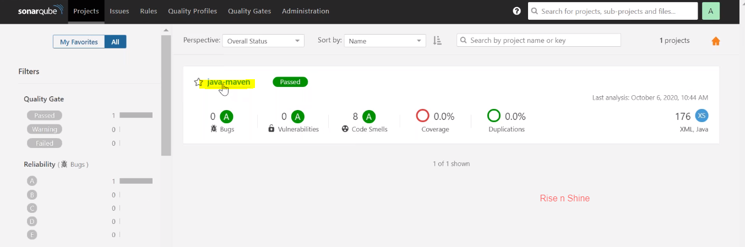

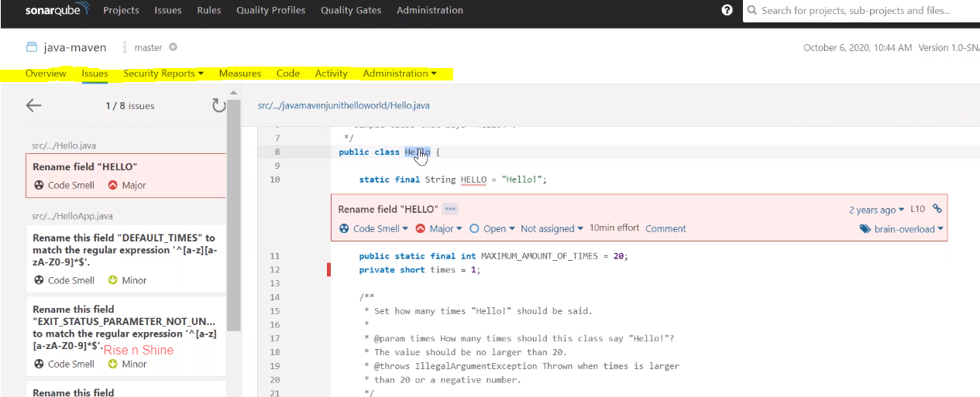

***

-sonar is check the coding standards developer will check the standards we just need to integrate with Jenkins

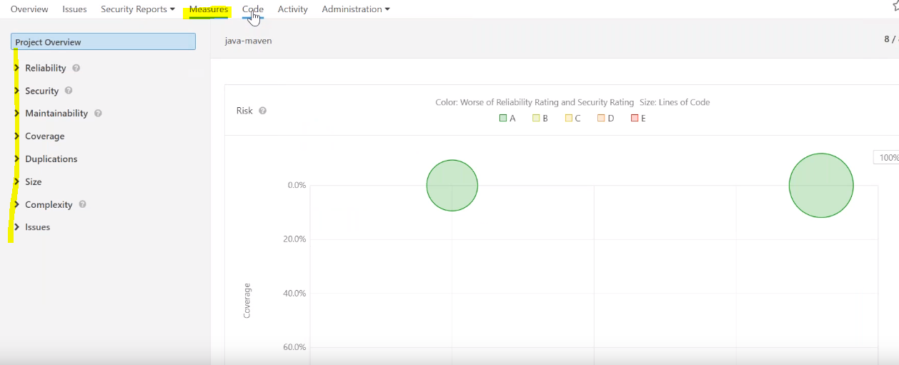

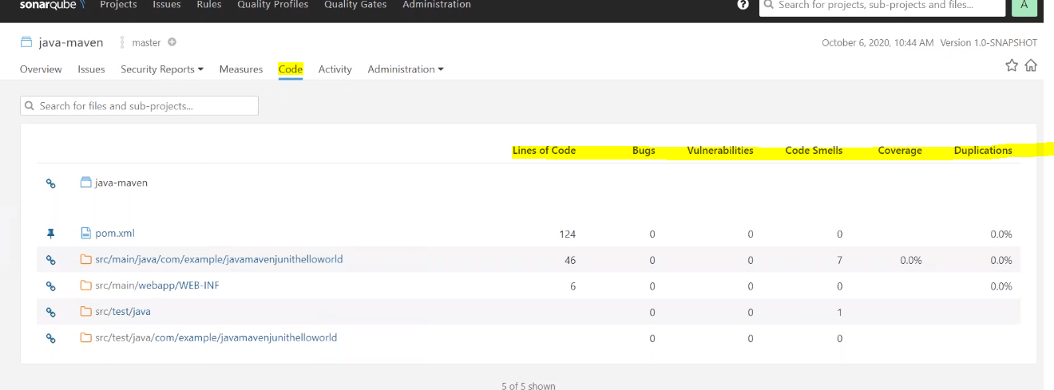

-Developers will define rules also in the code

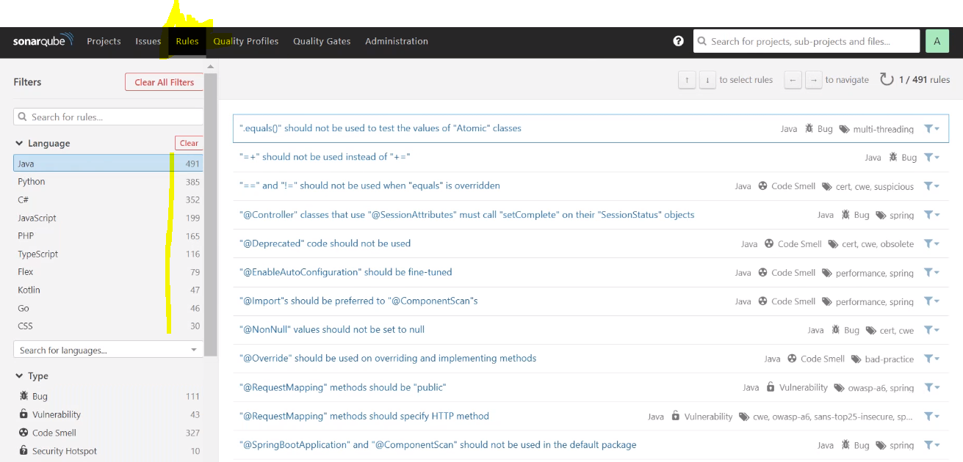

-comment the unnecessary steps otherwise it will take much time to run the complete build

-Now we need to run the Unit Test cases by using below code in the Jenkinsfile

stage('Unit Test Cases') {

agent {

label 'BuildServer'

}

steps{

sh "${mvnHome}/bin/mvn clean test"

}

post{

success{

junit 'target/surefire-reports/*.xml'

}

}

}

-and run the build and check

-and next we need to build the code / packaging the app and publish the artifacts by using below code in JenkinsFile

stage('Build Code') {

agent {

label 'BuildServer'

}

steps{

unstash ‘Source’

sh "${mvnHome}/bin/mvn clean package"

}

post{

success{

archiveArtifacts '**/*.war'

}

}

}

***

1. Stash

-if we like to use the same source code in the next steps we need to use this option

2.Unstash

-if we **don’t** like to use the same source code in the next steps we need to use this option

-in above code we used unstash option otherwise it will pull the code again

-if the same node not required to use this options, if we use many nodes then it will be useful

-now run the build and check again for any failures

-if it success it will create war file and publish the artifact

-now build successful and it will create test cases also

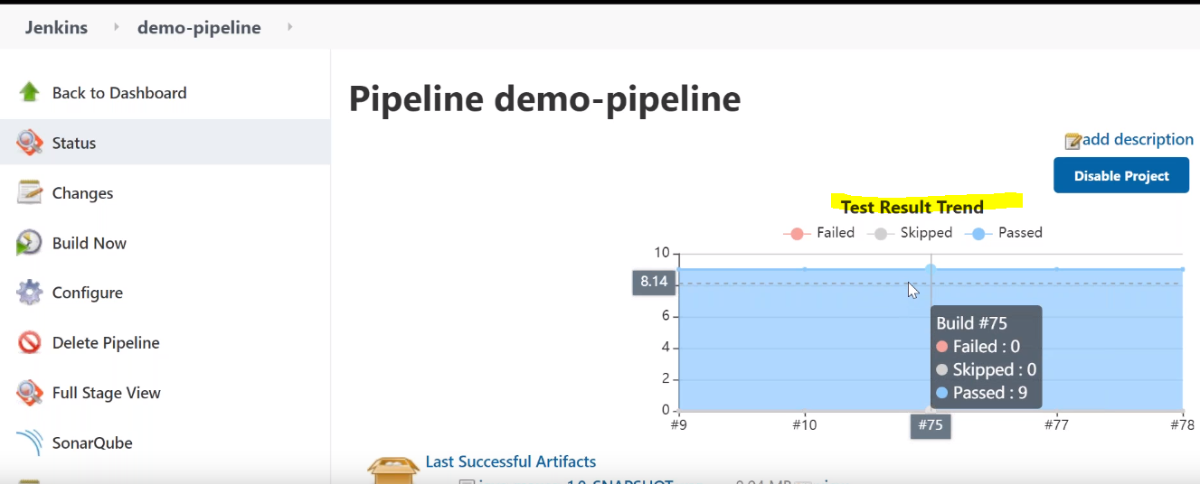

-and generated .war file

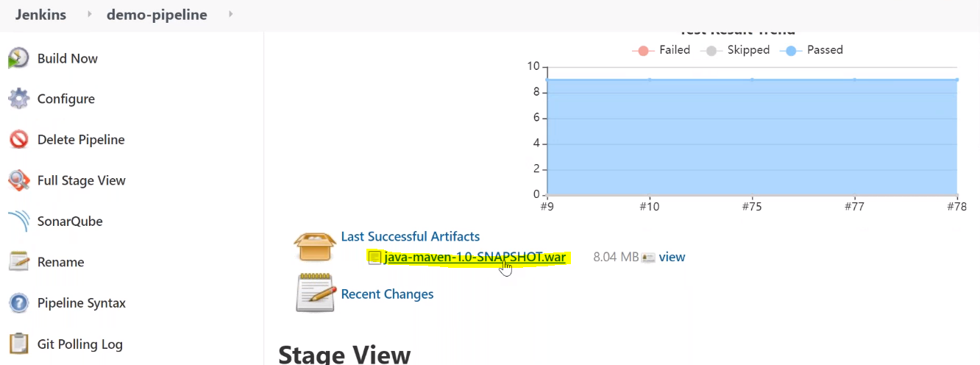

-next we need to build docker image and publishing the docker image

-by using below dockerfile

Dockerfile:

FROM centos

LABEL Maintainer=RNS Email=rns@rnstech.com

RUN yum update -y

RUN yum -y install java

RUN java -version

#RUN mkdir /opt/tomcat/

WORKDIR /opt

RUN curl -O http://mirrors.estointernet.in/apache/tomcat/tomcat-8/v8.5.50/bin/apache-tomcat-8.5.50.tar.gz

RUN tar xzvf apache-tomcat-8.5.50.tar.gz -C /opt/

RUN cp -R /opt/apache-tomcat-8.5.50/ /opt/tomcat

WORKDIR /opt/tomcat/webapps

COPY target/*.war /opt/tomcat/webapps/webapp.war

EXPOSE 8080

ENTRYPOINT ["/opt/tomcat/bin/catalina.sh", "run"]

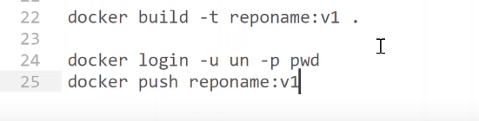

-before that we need to have repository to be created in docker hub

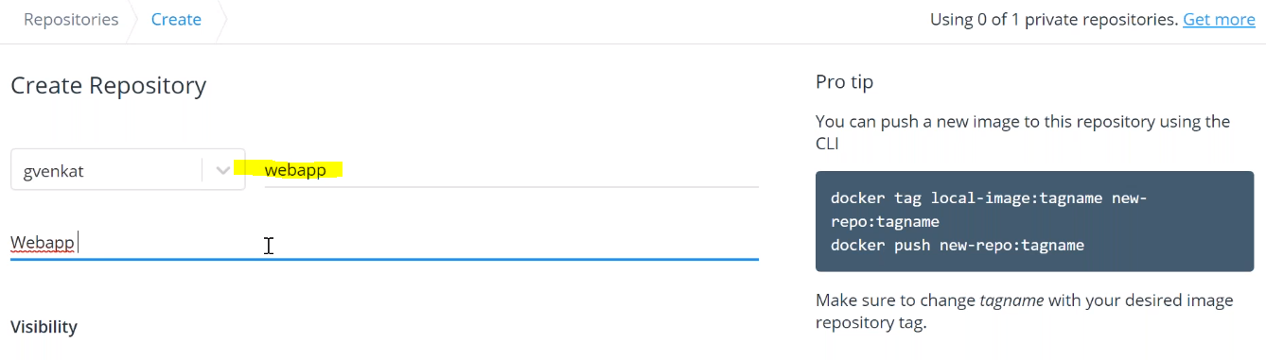

-repo created

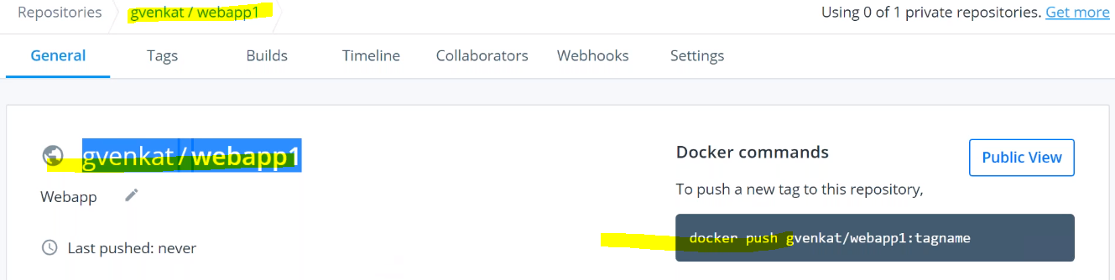

-Now we are going build docker image by using below code in Jenkinsfile

stage('Build Docker Image') {

agent {

label 'BuildServer'

}

steps{

sh "docker build -t gvenkat/batch21webapp ."

}

}

-run the build and check docker image created or not

-now we need to push the docker image to dockerhub repository

-before that we need to login with user name and password to docker hub

-for this we are not adding UN and PWD in the Jenkinsfile directly, we are going to create parameters and credentials in the Jenkins console and then we can add those credentials details in the file with parameters passing

-go to credentials section in Jenkins console and create/add the credentials:

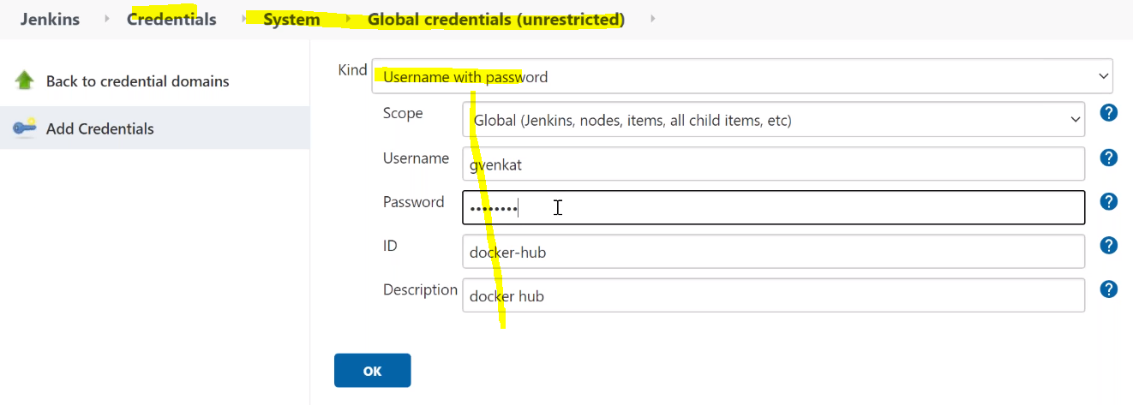

-for adding these credentials we have option like withCredentials() options like below code in the Jenkinsfile

stage('Publish Docker Image') {

agent {

label 'BuildServer'

}

steps{

withCredentials([usernamePassword(credentialsId: 'docker-hub', passwordVariable: 'dockerPassword', usernameVariable: 'dockerUser')]) {

sh "docker login -u ${dockerUser} -p ${dockerPassword}"

}

sh "docker push gvenkat/batch21webapp"

}

}

-we are going to create credentials using pipeline syntax options with using

**withCredentials: Bind credentials to variables** option

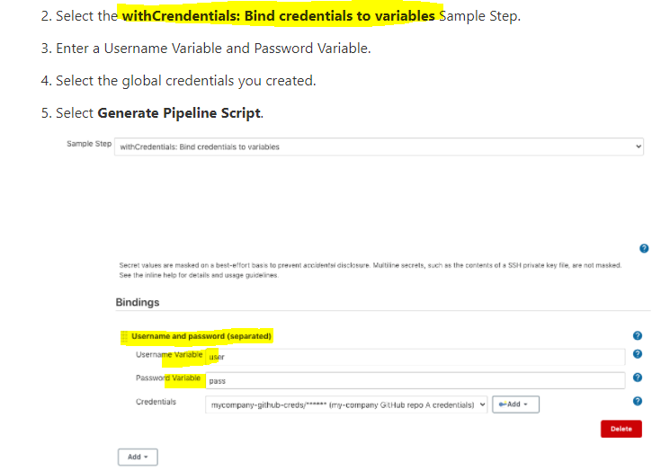

-run the build and check the docker image uploaded in the docker hub or not

-next we need to deploy the docker image from docker hub to kops cluster in the staging namespace as deploy image as Pod

-for this we need to have deploy-webapp.yml and service.yml file for pulling image from docker hub and deploy as a pod and run as a service

Deploy-webapp.yml :

apiVersion: v1

kind: Pod

metadata:

name: webapp

namespace: staging

labels:

app: webapp

spec:

containers:

- name: webapp

image: gvenkat/batch21webapp:latest

imagePullPolicy: Always

ports:

- containerPort: 8080

Service.yml file:

kind: Service

apiVersion: v1

metadata:

name: webapp

namespace: staging

spec:

selector:

app: webapp

ports:

- protocol: TCP

port: 80

targetPort: 8080

type: LoadBalancer

-now we are adding below code in Jenkinsfile for deploying the app by using above yml files locations mentioning like below

stage('Deploy to Staging') {

agent {

label 'BuildServer'

}

steps{

//Deploy to K8s Cluster

echo "Deploy to Staging Server"

sshCommand remote: remote1, command: "cd Maven-Java-Project; git pull"

sshCommand remote: remote1, command: "kubectl apply -f Maven-Java-Project/k8s-code/staging/app/."

}

}

-next run build and check Loadbalcer created or not in AWS console

-also check kops system about docker image and namespaces, pods and services

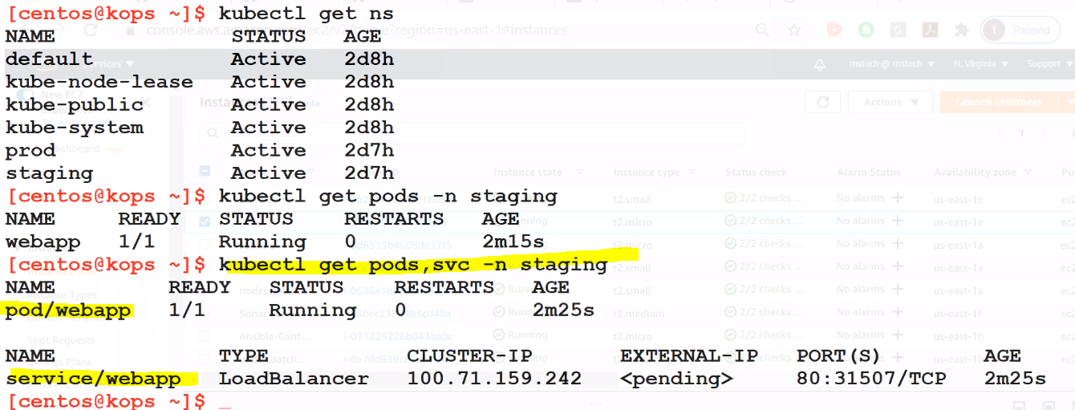

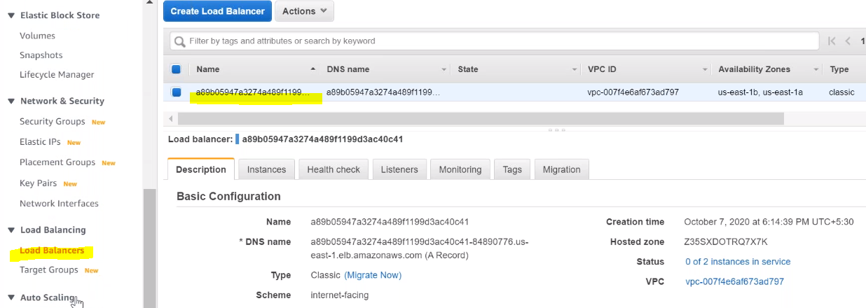

-check the Load balancer URL and check the application deployed successfully or not in browser

-if it not showing the app remove the registered in the LB section and add again

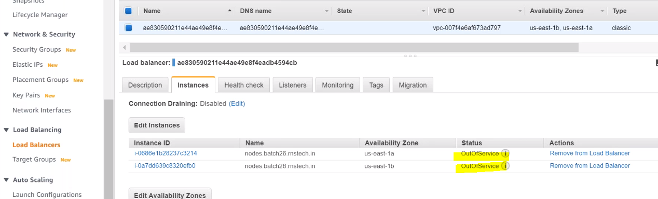

-now check the LB Url in web browser

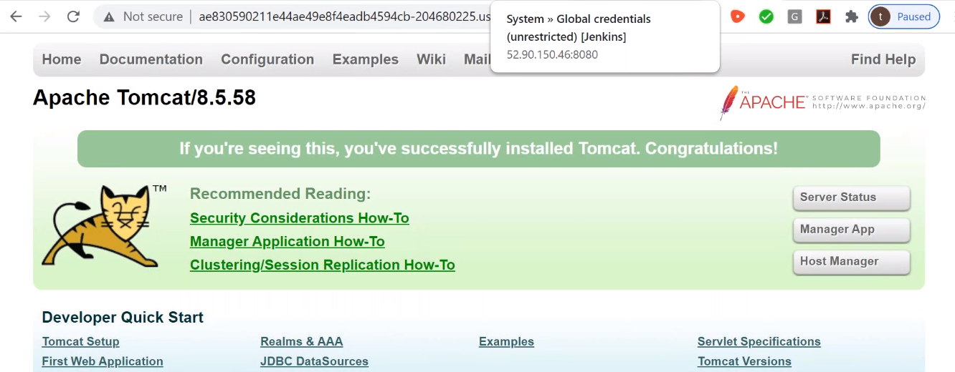

-finally we got accessing the application

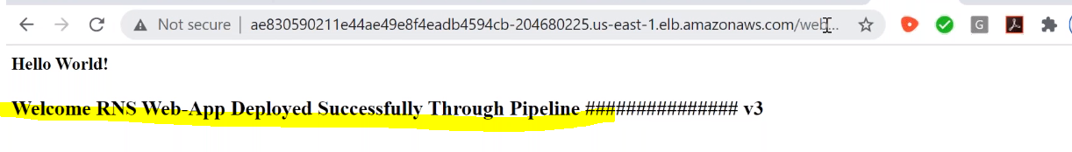

-now we successfully deployed application on the pods using docker and K8s

-now we need to run integration test cases by adding below code in the Jenkinsfile

stage ('Integration-Test') {

agent {

label "BuildServer"

}

steps {

echo "Run Integration Test Cases"

unstash 'Source'

sh "'${mvnHome}/bin/mvn' clean verify"

}

}

-run the build and check the test cases triggered or not

-next we are deploy application manually with approval option

-for this we need to create code for **timeout: Enforce time limit** options in pipeline syntax editor

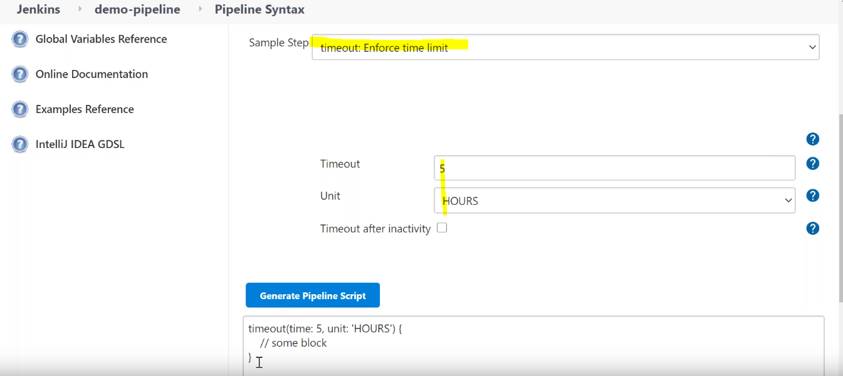

-now we need to add below code in JenkinsFile

stage ('approve') {

agent {

label "BuildServer"

}

steps {

echo "Approval State"

timeout(time: 7, unit: 'DAYS') {

input message: 'Do you want to deploy?', submitter: 'admin'

}

}

}

-if submitter (admin) approved the deployment it will deploy the app in production servers using below code

-so add below code in Jenkinsfile

stage ('Prod-Deploy') {

agent {

label "BuildServer"

}

steps{

echo "Deploy to Production"

//Deploy to Prod K8s Cluster

sshCommand remote: remote1, command: "cd Maven-Java-Project; git pull"

sshCommand remote: remote1, command: "kubectl apply -f Maven-Java-Project/k8s-code/prod/app/."

}

}

}

}

-run the build and check app deployed in Production servers or not

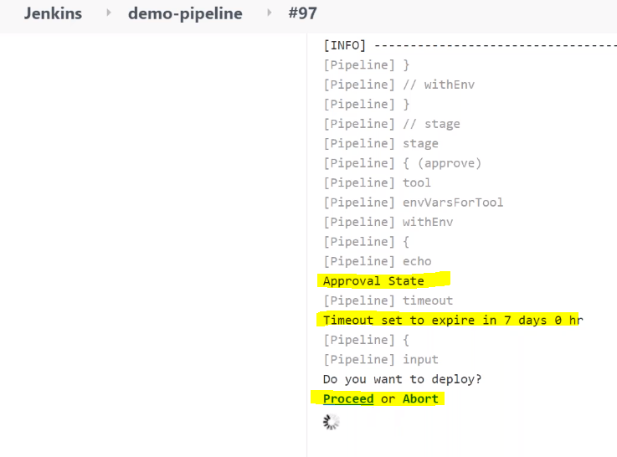

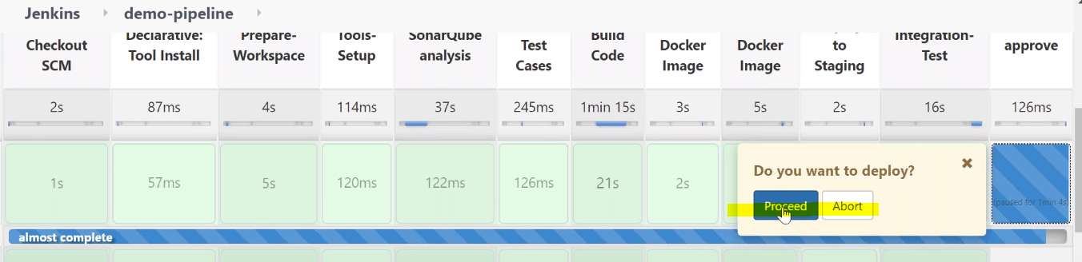

-after approval it will deploy app to production and it will create another Load balancer as per below prod-webapp.yml and service.yml files

Prod-deploy-webapp.yml file:

apiVersion: v1

kind: Pod

metadata:

name: webapp

namespace: prod

labels:

app: webapp

spec:

containers:

- name: webapp

image: gvenkat/batch21webapp:latest

imagePullPolicy: Always

ports:

- containerPort: 8080

Service.yml file:

kind: Service

apiVersion: v1

metadata:

name: webapp

namespace: prod

spec:

selector:

app: webapp

ports:

- protocol: TCP

port: 80

targetPort: 8080

type: LoadBalancer

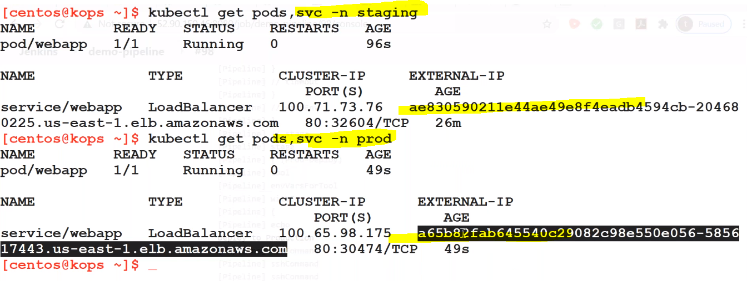

-now check with prod load balancer URL in web browser for accessing the application

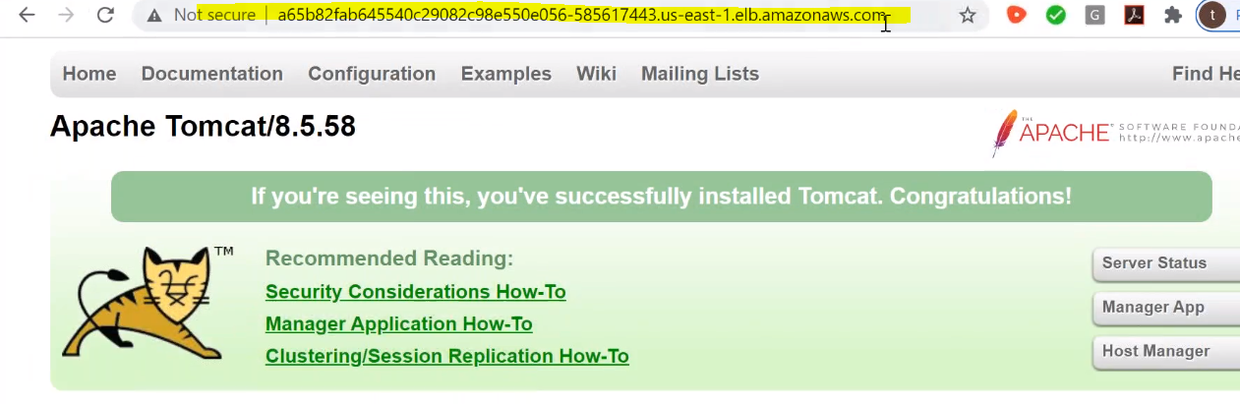

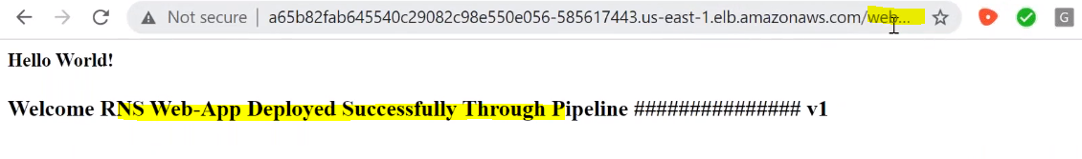

-now we successfully deployed the application in production servers

-so finally we created CI-CD pipeline to deploy the application on staging and production servers using git, maven, docker, ansible, sonar, k8s, aws, jenkins